## Yoobee College of Creative Innovation – Christchurch Campus

## Diploma in Software Development 2202- Online DSD

## CS101 UX Principles I : Project Research, Redesign, and Develop a Webpage

## Finlay Macbeth

## [270177904@yoobeestudent.ac.nz](mailto:270177904@yoobeestudent.ac.nz)

## Project Resit Date: Resit 9/05/22 – 16/05/22

Contents

Development Process 1

Prototype Vs. Website Comparison 1

Problems Faced 2

User Testing 2

Screenshots (compatibility / validation) 2

## Development Process

In order to develop my design into a functional website, I referred to the Figma Prototype almost constantly, using CSSGrid to place the content, and toying with different functions like float, margin, and padding in order to arrange the contents as portrayed by my Figma Design. I wanted to achieve the predesigned look, by using the same colours, fonts, style, and general layout as the Figma Design. I even ensured to import the font library into the html from: <https://fonts.googleapis.com/css2?family=Inter:wght@100;200;300;400;500;600;700;800;900&display=swap> . Aside from this, I knew that it was important to have a responsive site, so began to design the site to fit into a resolution fit for a large Android Cellphone, and worked my way up to a tablet, and then checked the Desktop sizing.

Prototype Vs. Website Comparison

Prototype Coded Website

Prototype Coded Website

As shown above, we can see the evolving process used to transform the Prototype image into a live copy coded and displayed by a browser. The use of CSS Grid and padding / margins helped greatly to dynamically arrange content in a pleasing manner akin to the prototype.

## Problems Faced

I faced some problems with alignment in the navigation bar due to different div containers, and flex. Unfortunately I didn’t end up solving it entirely – according to the prototype, but was able to come close, and get it functioning. I also initially approached the content layout with div containers alone, and tried to use css flex alone. This was obviously not doing the job, and switched up to CSS grid, which handled a whole array of alignment at once, enabling the look necessary.

## User Testing

User Testing was carried out from 6 individual users and the feedback can be summarized as follows

* Some features are incomplete or missing ‘please fix’
* Some Content was either too large (some images) or too small (some text) please bridge the gap and allow for better legibility.
* Content doesn’t display correctly on some isolated devices ‘please fix’
* Header not prominent enough , nor is banner, banner not hideable ‘please fix’

## Screenshots (compatibility / validation)

* A screenshot of a video game

  Description automatically generatedGraphical user interface, website

  Description automatically generatedResponsiveness
* Phone Tablet

Desktop

Browser Compatibility: To save on space, all screenshots above were using Opera GX Browser, I shall proceed to document Chrome, and Firefox Browsers below:

Chrome Browser Firefox Browser

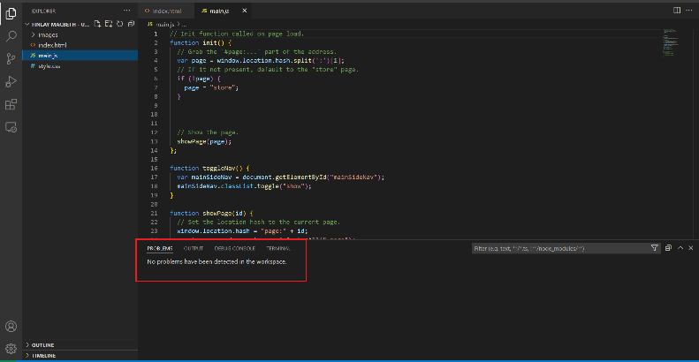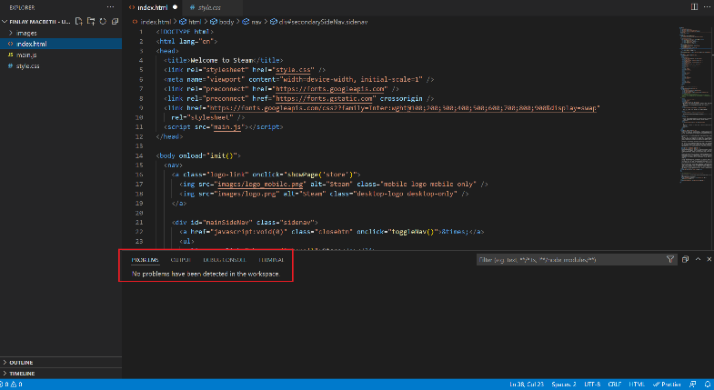Validation: Using extensions in VS Code, I was able to determine that there were no bugs in the code.

Html CSS

Javascript – Left.